**European** GNSS supports smarter mobility

***Published:***

*17 September 2019*

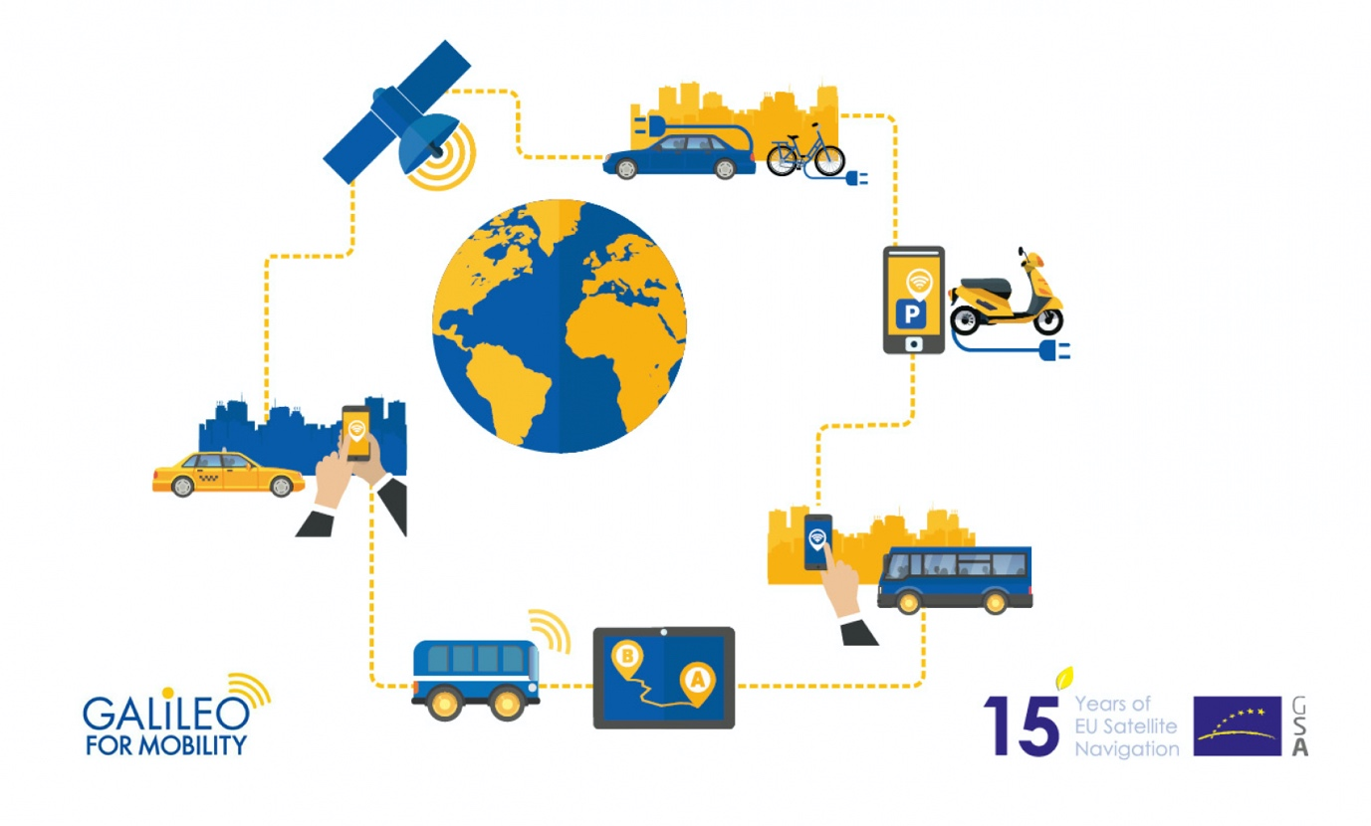

*Galileo and EGNOS are supporting the smart mobility solutions of the future*

**Over the past few months, we have published a number of articles highlighting how GNSS is contributing to technological advancements in various transport sectors.**[**Mobility Week**](http://www.mobilityweek.eu/)**is a good opportunity to look back at these and summarise how Galileo and EGNOS are enabling the intelligent transport applications that underpin the mobility solutions of the future.**

Following the first [Space for Innovation in Rail](https://www.gsa.europa.eu/newsroom/news/space4rail-innovation-implementation) conference, held in Vienna back in March, we had a number of articles on the contribution of space to the modernisation of the rail sector. One of these featured leading Italian rail infrastructure manager [Rete Ferroviaria Italiana](https://www.gsa.europa.eu/newsroom/news/egnss-and-ertms-win-win-both-rail-and-space) (RFI), an early adopter of the European Rail Traffic Management System (ERTMS) and a company that has been quick to appreciate the benefits of using satellite positioning in the rail sector.

GNSS and the ERTMS are perfect complementary assets that can together considerably reduce rail operational costs. However, with new technologies such as GNSS, obstacles still remain to ensuring interoperability and open standards, and these obstacles require solutions to be developed by all stakeholders involved. This is something that the ERSAT ([ERTMS on Satellite](https://www.gsa.europa.eu/ertms-satellite-%E2%80%93-enabling-application-validation)) project, co-funded by the GSA, aims to address.

**Watch this**: [EGNOS and Galileo for Rail](https://www.gsa.europa.eu/library/videos?search=&field_video_gallery_topic_tid=1115&field_video_gallery_language_value_1=All&sort_by=field_video_gallery_date_value&sort_by=field_video_gallery_date_value)

This project targets the integration of GNSS positioning and public telecommunications over the ERTMS platform and is making an effective roadmap to allow others to follow a step-wise operational deployment. The ERSAT project has field-tested and demonstrated the capability of satellite-based positioning embedded within the ERTMS ecosystem. This has caught the eye of many train operators in Europe and beyond.

**Boosting customer services**

Once such operator is French national rail company SNCF, which is taking the [lead in adopting Galileo technology to boost customer services](https://www.gsa.europa.eu/newsroom/news/french-railways-embrace-galileo), in particular in its high-speed TGV network. The company is already embracing GNSS-based systems, especially for passenger information, and fleet and traffic management. “At the beginning of 2019, some 250 high-speed trains were already equipped with Galileo-ready receivers. This represents nearly 50% of SNCF’s TGV fleet. Some 320 trains are expected to be Galileo-ready by the end of 2019,” said Antoine Barre, head of train localisation projects at SNCF. SNCF aims to equip its entire train fleet with Galileo receivers to assist non-safety relevant train localisation, and also plans to further investigate the future contribution of European GNSS within the ERTMS.

**And this**: [Driving with Galileo](https://youtu.be/OGnA-oiStJM)

**Supporting Mobility as a Service**

The benefits of EGNSS stretch beyond the rail sector, however. New urban mobility schemes are rapidly evolving due to social, economic and technological changes and, against this backdrop, Galileo can deliver new accuracy and reliability for location-dependent services that get people where they need to go. This is supported by the omnipresence of smart mobile devices, which is allowing new business models to emerge based on the sharing of goods and services - the so-called sharing economy.

The [Galileo 4 Mobility](http://www.galileo4mobility.eu/) project is working to promote the introduction of Galileo technology within the MaaS context by analysing the geolocation needs of the different stakeholders involved and demonstrating the benefits of Galileo through pilot demonstrators of shared mobility services. GALILEO 4 MOBILITY encompasses a number of MaaS-oriented pilots, including a [ride-sharing service in Thessaloniki](https://www.gsa.europa.eu/newsroom/news/galileo-supporting-mobility-service), Greece.

**Changing the way we fly**

It is not just land-based transport that is benefiting from space-based solutions. In aviation too, EGNSS is also helping make transport cleaner, safer and more accessible, EGNOS and Galileo contribute to landing, surveillance and Search and Rescue operations, and actions targeting every aviation user. These benefits of EGNOS were in focus at the [AERO International General Aviation Fair](https://www.gsa.europa.eu/newsroom/news/egnss-enabling-change-general-aviation) at Friedrichshafen, Germany, back in May.

**And this**: [EGNOS for Aviation](https://youtu.be/9oxSBPW5APk)

At the event, Julian Scarfe, deputy chairman of PPL/IR – Europe, the leading group for private pilots across Europe interested in instrument flying, spoke about easier access to instrument flight rules for general aviation through the use of EGNOS and localiser performance with vertical guidance (LPV). "Today we have EGNOS that can enable vertical approaches to non-instrument runways. The GSA is running a project to enable this. This will change the way we fly," he said.

Likewise, in an [interview with GSA](https://www.gsa.europa.eu/newsroom/news/flying-green-airbaltic), AirBaltic’s Senior Vice President for Flight Operations Pauls Cālītis spoke about how EGNOS is enabling the E-GEN project and the ’green flying’ concept, helping the airline to improve its efficiency  and reduce its environmental footprint and the level of emissions and noise that it produces.